1. Create a standard page layout (like an L-shaped screen).
2. Use images from the assets folder.
3. Divide the header into three sections. On small screens, combine them into one.
4. Clicking "Sign In" or "Sign Up" will open a modal.

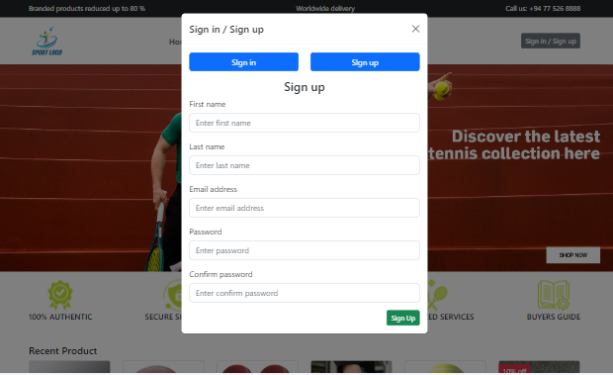

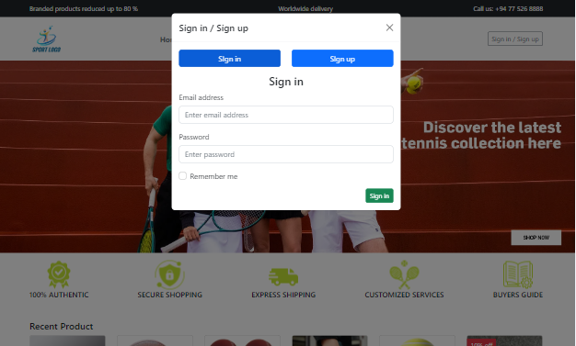

1. Provided screenshots for different screen sizes. Design the page to be responsive for large, medium, small, and extra small screens.
2. Include an image slider in the footer.

Only display this slider on large and medium screens; hide it on smaller screens.



1. On small and extra small screens, move the navigation bar to a side menu.
2. Make the navigation bar stick to the top of the page when scrolling on large and medium screens.